VPC-3
Scenario:
A large organization is migrating its on-premises infrastructure to the AWS cloud.
The organization's architecture involves multiple VPCs for different departments and applications, each requiring secure communication with centralized services and external resources.
The IT team needs to design and implement a scalable and efficient network architecture to accommodate the organization's growth and ensure robust connectivity between VPCs and external services.
Objectives:
- Design and deploy a scalable network architecture using AWS Transit Gateway to simplify network connectivity between multiple VPCs.
- Configure VPC endpoints to securely access AWS services without internet gateways or NAT gateways, ensuring data privacy and minimizing exposure to external threats.

Created different Instances, different VPCs, Subnets, route tables, Internet Gateways
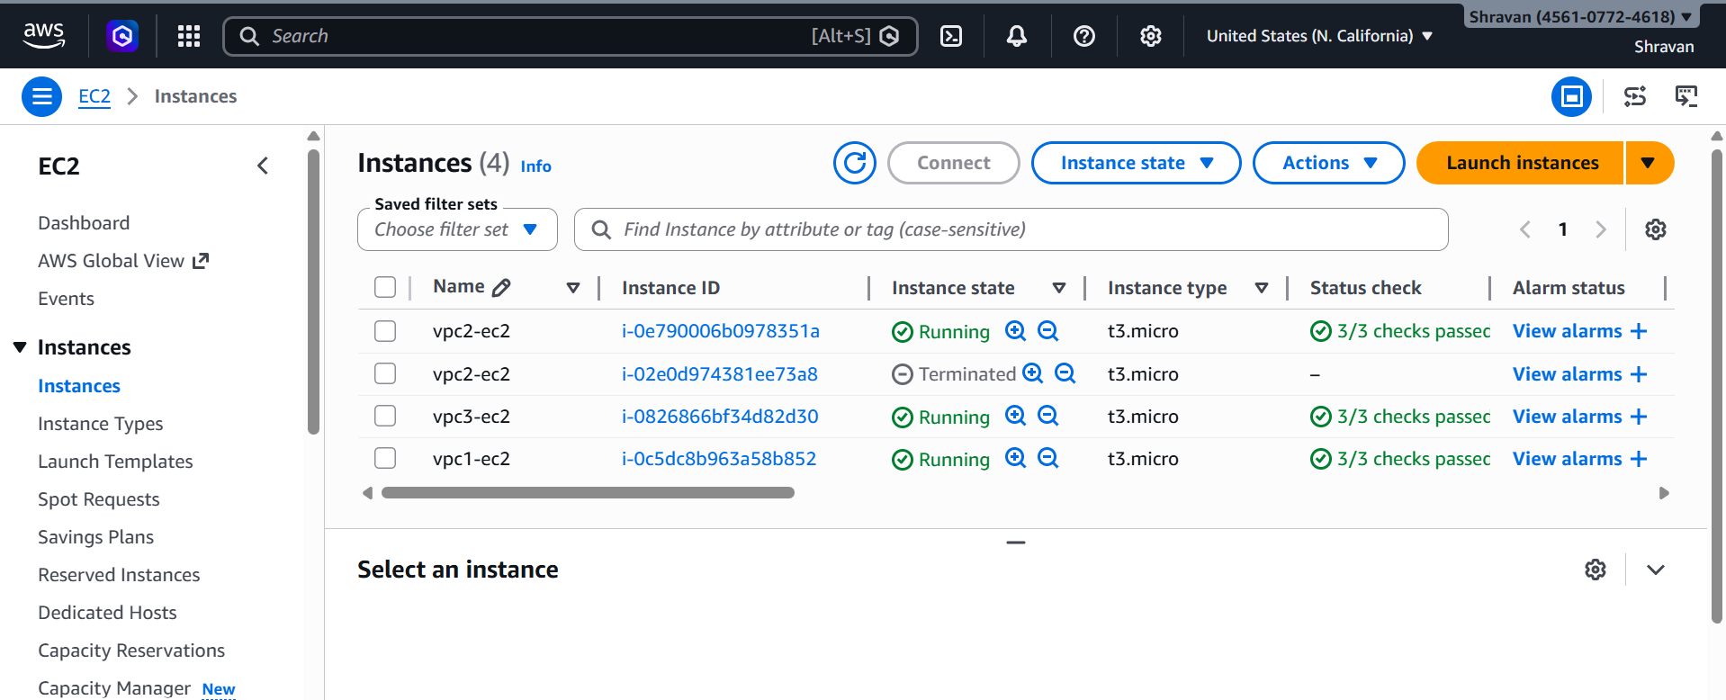
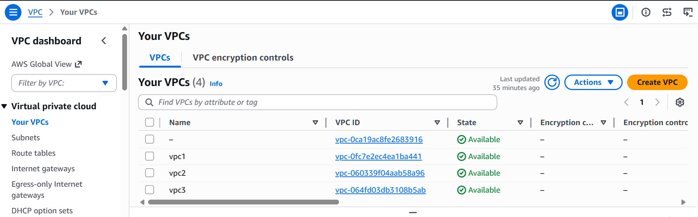
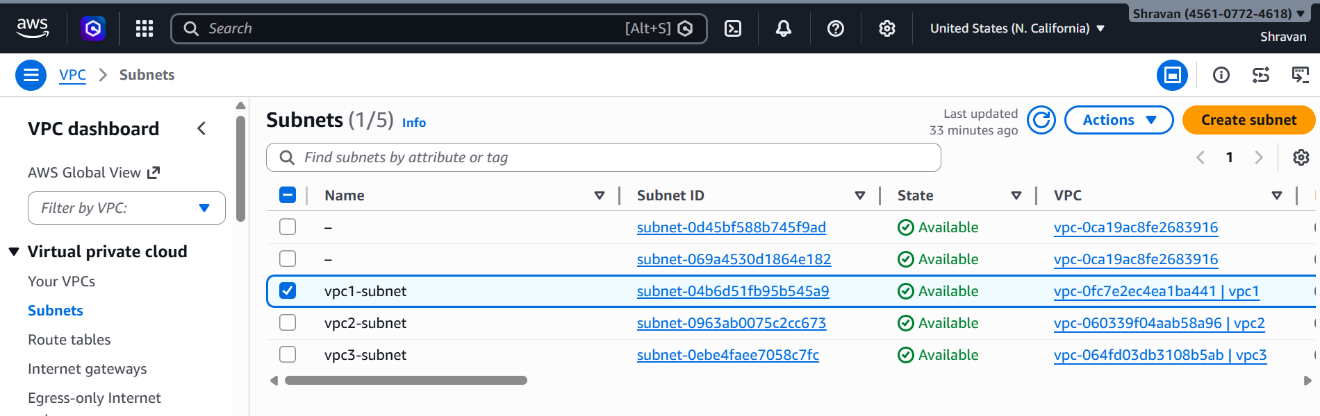
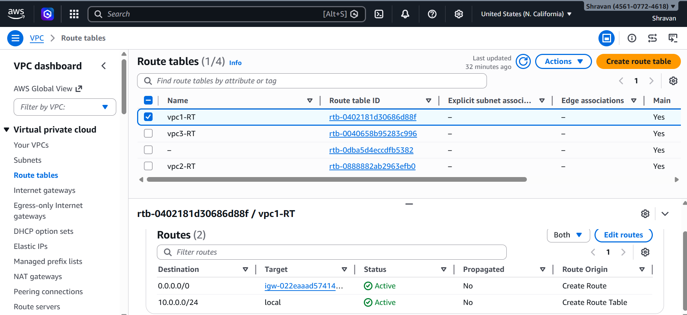
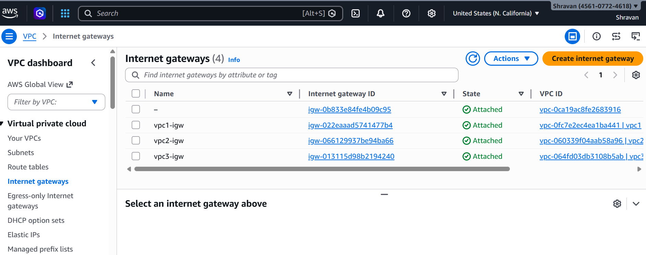
Security groups, Inbound rules
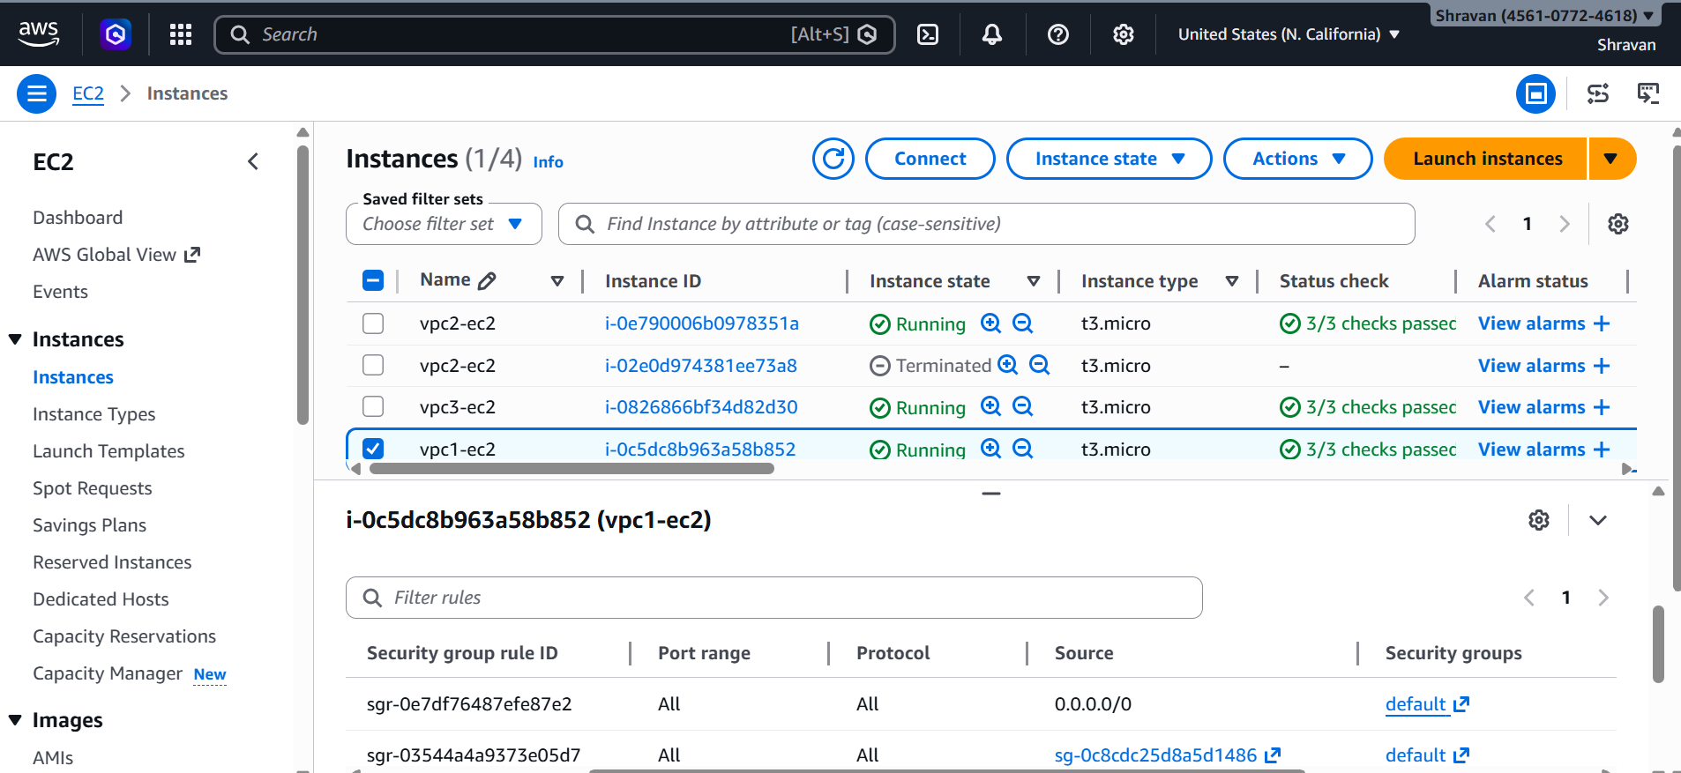
Create tgw & create tgw attachment
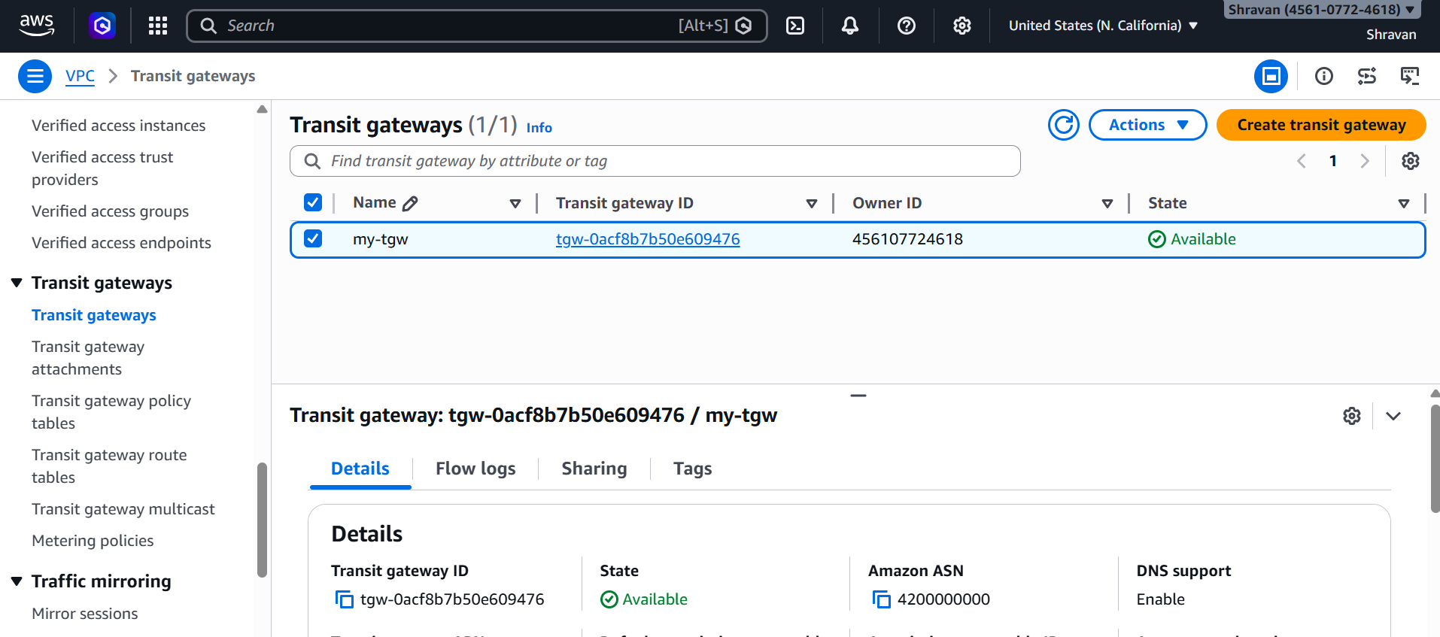

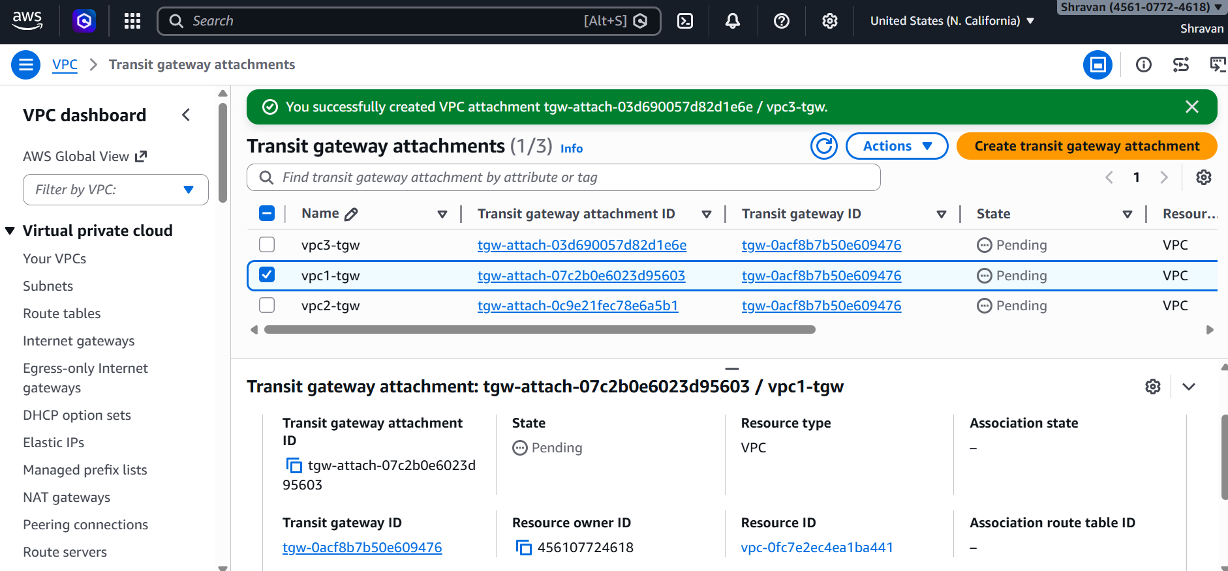
In Routes add all tgw for all different VPCs
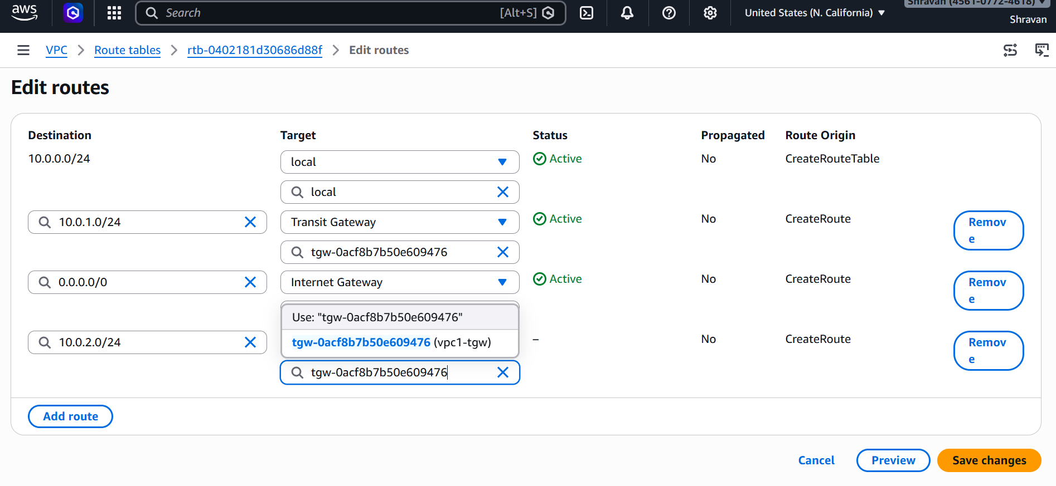
Now from public1 instance login and ping to other private instance so it will run
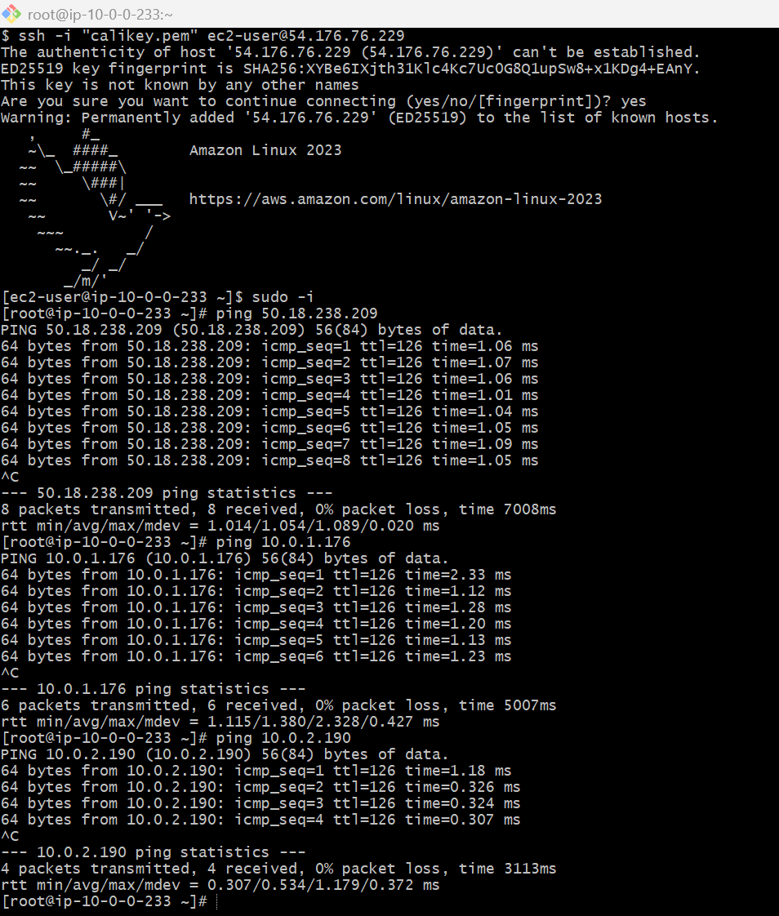
Configure VPC endpoints to securely access AWS services without internet gateways or NAT gateways, ensuring data privacy and minimizing exposure to external threats
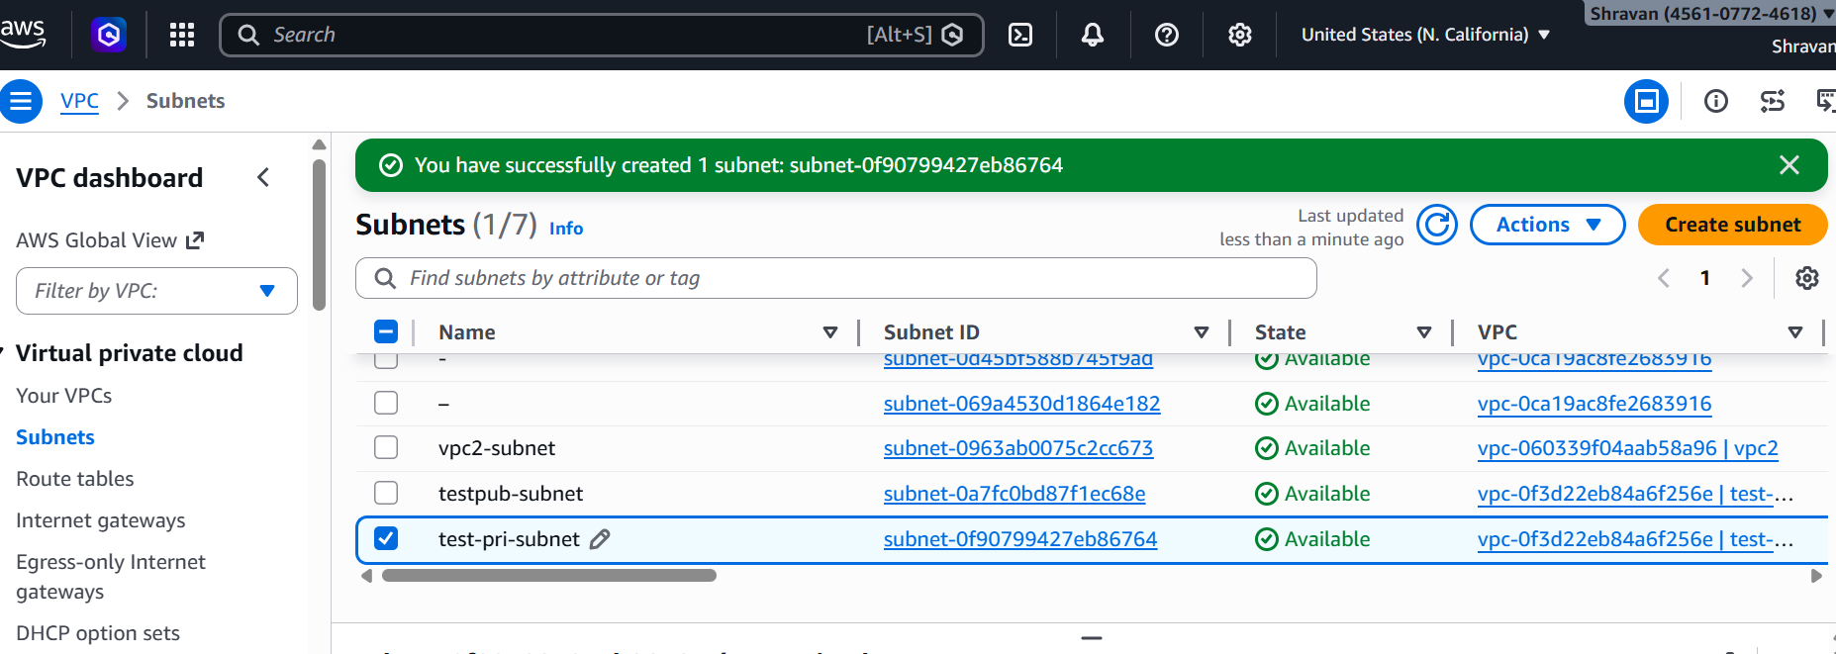
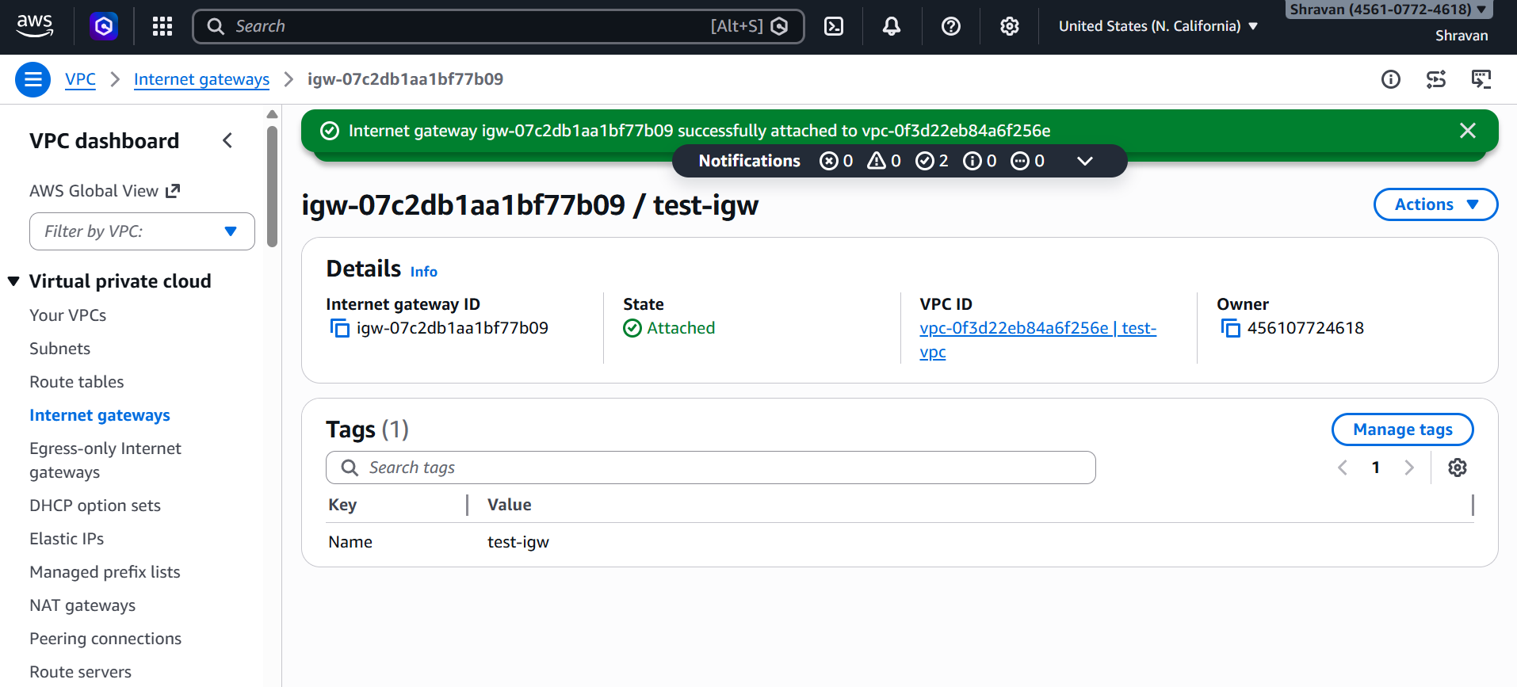
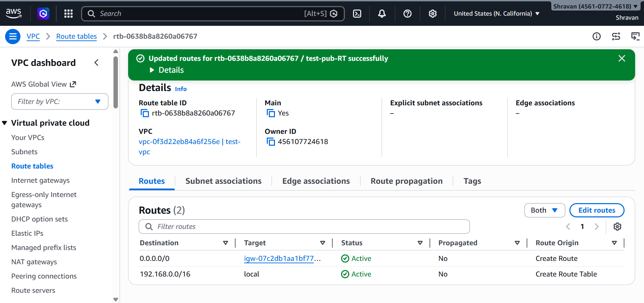
Create S3 Bucket
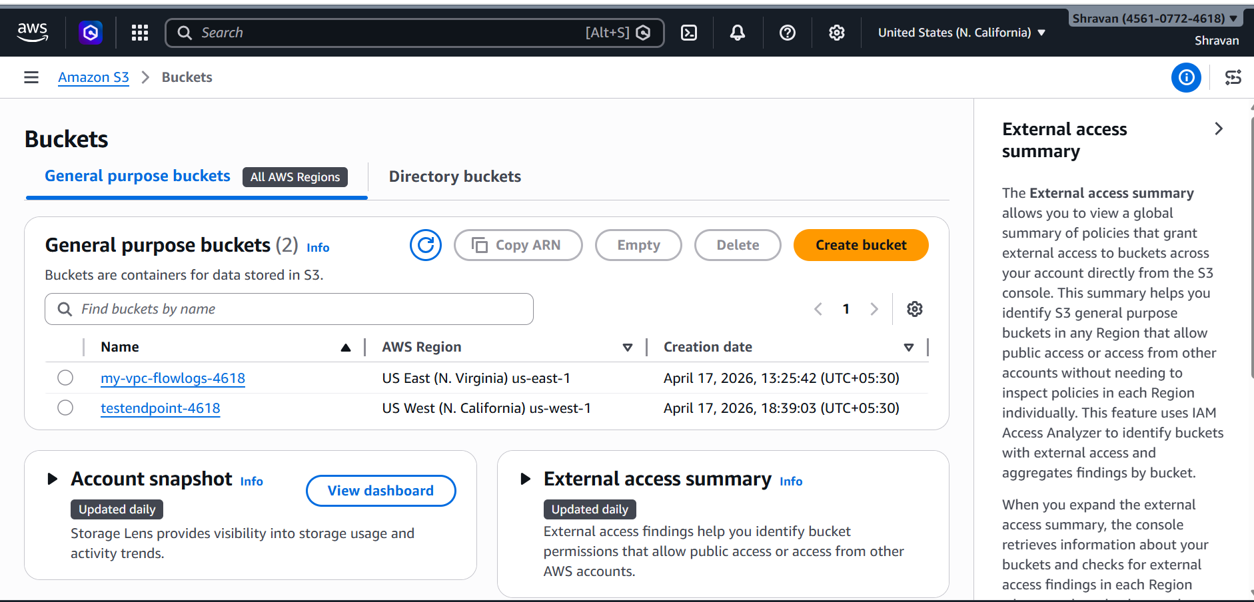
Create endpoint
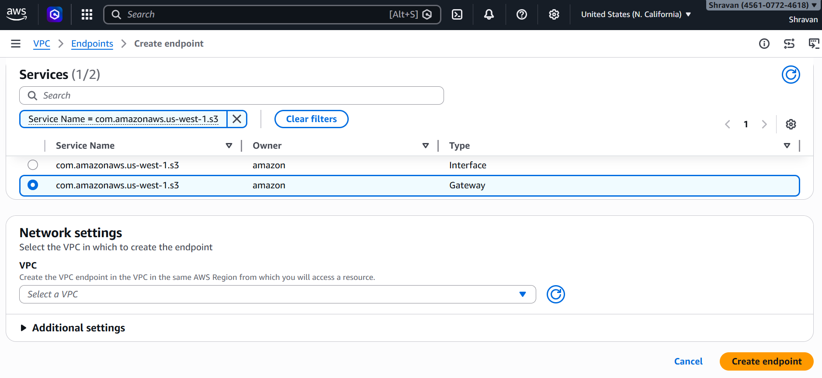
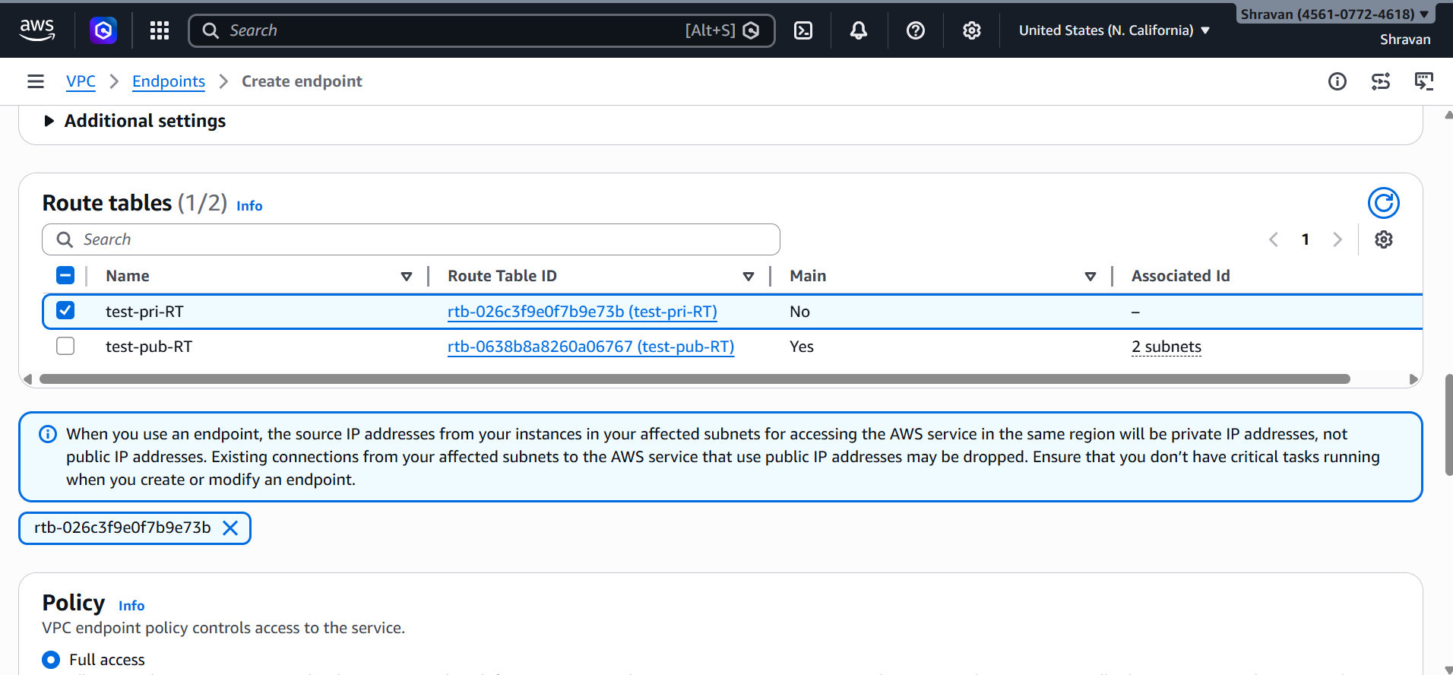
Create ec2 instance for public & private, in private disable public ip
